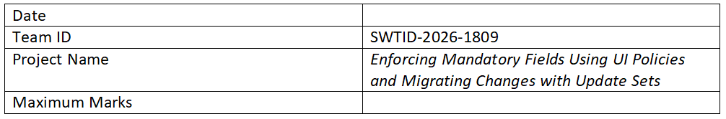

Project Design Phase-II

Technology Stack (Architecture & Stack)
Project Title: Enforcing Mandatory Fields Using UI Policies and Migrating Changes with Update Sets

Technical Architecture
This project is developed on the ServiceNow platform where UI Policies are used to enforce mandatory fields dynamically. Update Sets are used to migrate configurations and changes across different environments such as development, testing, and production. The system ensures data integrity and seamless deployment of configurations.

Table-1: Components & Technologies
S.No | Component | Description | Technology
1 | User Interface | User interacts via ServiceNow forms and dashboards | ServiceNow UI, HTML, CSS, JavaScript
2 | Application Logic-1 | UI Policies to enforce mandatory fields dynamically | ServiceNow UI Policies
3 | Application Logic-2 | Client Scripts for validation and dynamic behavior | JavaScript (ServiceNow)
4 | Application Logic-3 | Business Rules for backend validation | ServiceNow Business Rules
5 | Database | Stores records and configurations | ServiceNow Database (MySQL-based)
6 | Cloud Database | Managed database within ServiceNow cloud | ServiceNow Cloud
7 | File Storage | Stores attachments and update set data | ServiceNow Storage
8 | External API-1 | Integration if required | REST API
9 | External API-2 | Optional integrations | SOAP/REST
10 | Infrastructure | Cloud-based deployment | ServiceNow Cloud Platform

Table-2: Application Characteristics
S.No | Characteristics | Description | Technology
1 | Open-Source Frameworks | Uses built-in ServiceNow frameworks | ServiceNow Platform
2 | Security Implementations | Role-based access control and data security | IAM, ACLs
3 | Scalable Architecture | Cloud-based scalable architecture | ServiceNow Cloud
4 | Availability | Highly available cloud platform | ServiceNow Infrastructure
5 | Performance | Optimized UI policies and scripts | ServiceNow Optimization Tools

